Making Donations to the MCF 2021 Festival during suspension
Even though your Lodge or Chapter activity is currently suspended due to Covid19 you can still make that regular ‘white envelope’ donation very simply! Instead of deacons coming round with a plate it can be done via your PC, Phone or tablet.
Follow these steps to make an online charity collection!
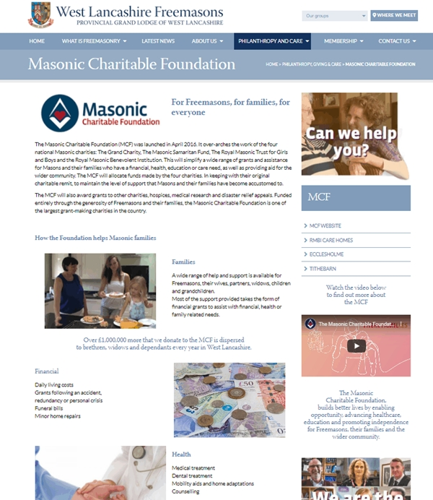
Log on the brand new West Lancashire Provincial website:www.westlancsfreemasons.org.uk
- Click on Philanthropy & Care and then select MCF website tab.
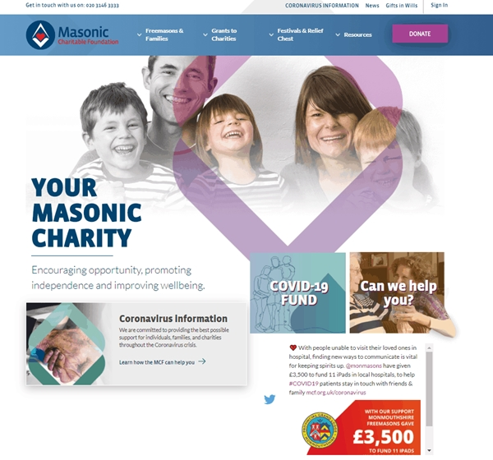
- Select ‘donate’.

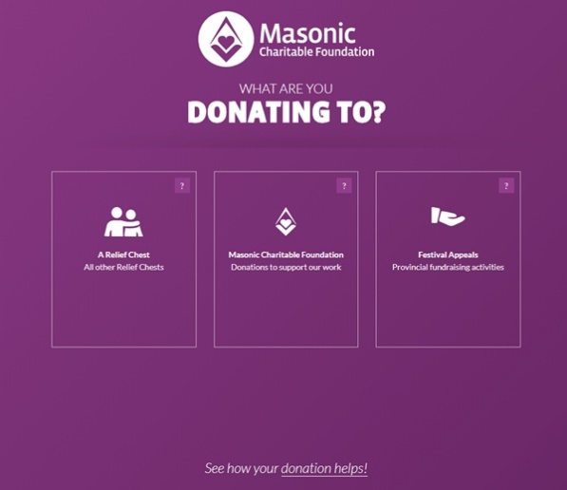
- Select ‘Festival appeal’
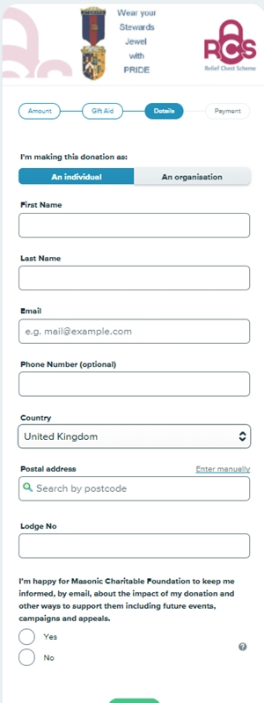
- Select single donation
- From next screen select ‘Festival’
- A Drop down appears from which you choose our province – West Lancashire
- Submit that information and you will then be asked how much. Decide how much you wish to donate to the festival – It’s just like putting cash in a white envelope and the amount you donate will be added to your Jewel patronage just like it is when you use the white envelope in lodge or chapter!
- You then get an option to gift aid the donation. Please do this if you are a tax payer as it boosts your donation by 25%!
- Once that’s done you simply fill in the next form which is really just like filling in the stub on the back of a traditional white envelope.
- Select next is like placing the envelope on the charity plate! Many thanks for your donation which the MCF will faithfully apply.
You can jump straight to the purple screen above by going to mcf.org.uk/donate or click on the purple screen shot.

